**COGNIZANT DIGI NURTURE 4.0**

**WEEK 7 MANDATORY HANDS ON BY (6377625)**

**REACT:**

**File no: 9**

**App.js**

import React from 'react';

import ListofPlayers from './ListofPlayers';

import IndianPlayers from './IndianPlayers';

function App() {

  const flag = true; // Change to false to switch components

  return (

    <div style={{ padding: '20px' }}>

      {flag ? <ListofPlayers /> : <IndianPlayers />}

    </div>

  );

}

export default App;

**IndianPlayers.js**

import React from 'react';

const IndianPlayers = () => {

  const oddPlayers = ["Sachin1", "Virat3", "Yuvaraj5"];

  const evenPlayers = ["Dhoni2", "Rohit4", "Raina6"];

  const T20Players = ["Mr. First Player", "Mr. Second Player", "Mr. Third Player"];

  const RanjiPlayers = ["Mr. Fourth Player", "Mr. Fifth Player", "Mr. Sixth Player"];

  const mergedPlayers = [...T20Players, ...RanjiPlayers];

  return (

    <div>

      <h2>Odd Players</h2>

      <ul>

        <li>First : {oddPlayers [0]}</li>

        <li>Third : {oddPlayers [1]}</li>

        <li>Fifth : {oddPlayers [2]}</li>

      </ul>

   <h1>_________________________________________</h1>

      <h2>Even Players</h2>

      <ul>

        <li>Second : {evenPlayers[ 0]}</li>

        <li>Fourth : {evenPlayers[ 1]}</li>

        <li>Sixth : {evenPlayers[ 2]}</li>

      </ul>

<h1>_________________________________________</h1>

      <h2>List of Indian Players Merged:</h2>

      <ul>

        {mergedPlayers.map((p, i) => (

          <li key={i}>{p}</li>

        ))}

      </ul>

    </div>

  );

};

export default IndianPlayers;

**ListofPlayers.js**

import React from 'react';

const ListofPlayers = () => {

  const players = [

    { name: "Mr. Jack", score: 50 },

    { name: "Mr. Michael", score: 70 },

    { name: "Mr. John", score: 40 },

    { name: "Mr. Ann", score: 61 },

    { name: "Mr. Elisabeth", score: 61 },

    { name: "Mr. Sachin", score: 95 },

    { name: "Mr. Dhoni", score: 100 },

    { name: "Mr. Virat", score: 84 },

    { name: "Mr. Jadeja", score: 64 },

    { name: "Mr. Raina", score: 75 },

    { name: "Mr. Rohit", score: 80 },

  ];

  const below70 = players.filter(player => player.score < 70);

  return (

    <div>

      <h2>List of Players</h2>

      <ul>

        {players.map((p, i) => (

          <li key={i}>{p.name} {p.score}</li>

        ))}

      </ul>

<h1>_________________________________________</h1>

      <h2>List of Players having Scores Less than 70</h2>

      <ul>

        {below70.map((p, i) => (

          <li key={i}>{p.name} {p.score}</li>

        ))}

      </ul>

    </div>

  );

};

export default ListofPlayers;

**App.css**

.App {

  text-align: center;

}

.App-logo {

  height: 40vmin;

  pointer-events: none;

}

@media (prefers-reduced-motion: no-preference) {

  .App-logo {

    animation: App-logo-spin infinite 20s linear;

  }

}

.App-header {

  background-color: #282c34;

  min-height: 100vh;

  display: flex;

  flex-direction: column;

  align-items: center;

  justify-content: center;

  font-size: calc(10px + 2vmin);

  color: white;

}

.App-link {

  color: #61dafb;

}

@keyframes App-logo-spin {

  from {

    transform: rotate(0deg);

  }

  to {

    transform: rotate(360deg);

  }

}

**OUTPUT:**

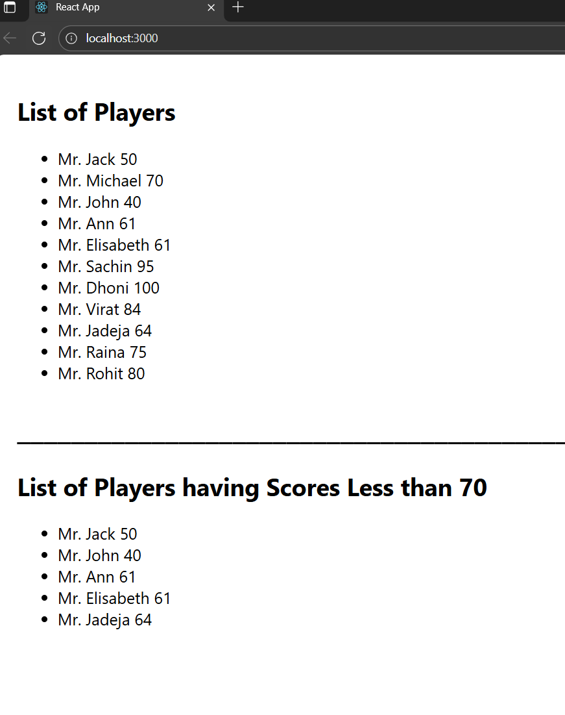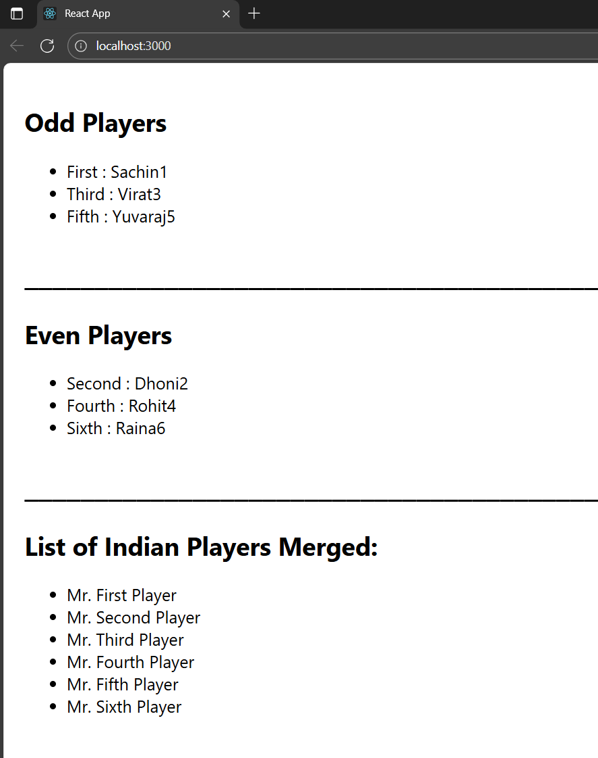

File no.:10:

**App.js**

import React from 'react';

function App() {

const heading = "Office Space , at Affordable Range";

// Office object

const office = {

name: "DBS",

rent: 50000,

address: "Chennai",

image:

};

// Inline style for rent color

const rentStyle = {

color: office.rent < 60000 ? "red" : "green",

fontWeight: "bold"

};

return (

<div style={{ padding: "20px", fontFamily: "Arial" }}>

<h1>{heading}</h1>

<img src={office.image} alt="Office Space" width="300" height="200" />

<h2>Name: {office.name}</h2>

<p style={rentStyle}>Rent: Rs. {office.rent}</p>

<p><strong>Address:</strong> {office.address}</p>

</div>

);

}

export default App;

**App.css**

.App {

  text-align: center;

}

.App-logo {

  height: 40vmin;

  pointer-events: none;

}

@media (prefers-reduced-motion: no-preference) {

  .App-logo {

    animation: App-logo-spin infinite 20s linear;

  }

}

.App-header {

  background-color: #282c34;

  min-height: 100vh;

  display: flex;

  flex-direction: column;

  align-items: center;

  justify-content: center;

  font-size: calc(10px + 2vmin);

  color: white;

}

.App-link {

  color: #61dafb;

}

@keyframes App-logo-spin {

  from {

    transform: rotate(0deg);

  }

  to {

    transform: rotate(360deg);

  }

}

**reportWebVitals.js**

const reportWebVitals = onPerfEntry => {

  if (onPerfEntry && onPerfEntry instanceof Function) {

    import('web-vitals').then(({ getCLS, getFID, getFCP, getLCP, getTTFB }) => {

      getCLS(onPerfEntry);

      getFID(onPerfEntry);

      getFCP(onPerfEntry);

      getLCP(onPerfEntry);

      getTTFB(onPerfEntry);

    });

  }

};

export default reportWebVitals;

**OUTPUT:**

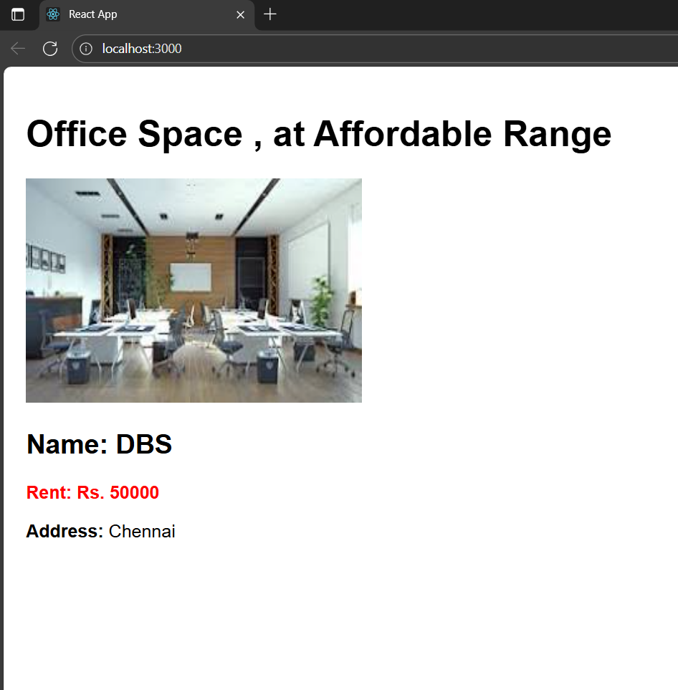

File no : 11 eventexamplesapp

CurrencyConverter.js

import React, { Component } from 'react';

class CurrencyConvertor extends Component {

  constructor(props) {

    super(props);

    this.state = {

      amount: '',

      currency: ''

    };

  }

  handleChange = (e) => {

    this.setState({ [e.target.name]: e.target.value });

  };

  handleSubmit = (e) => {

    e.preventDefault();

    const { amount, currency } = this.state;

    const num = parseFloat(amount);

    if (isNaN(num)) {

      alert('Invalid amount');

      return;

    }

    const cur = currency.trim().toLowerCase();

    let converted = null;

    if (cur === 'euro') {

      converted = num * 80;

      alert(`Converting to Euro Amount is ${converted}`);

    } else if (cur === 'usd') {

      converted = num * 83.5;

      alert(`Converting to USD Amount is ${converted.toFixed(2)}`);

    } else if (cur === 'inr') {

      converted = num;

      alert(`Converting to INR Amount is ${converted.toFixed(2)}`);

    } else {

      alert('Unsupported currency. Use Euro, USD, or INR');

    }

  };

  render() {

    return (

      <div style={{ marginTop: 30 }}>

        <h1 style={{ color: 'green' }}>Currency Convertor!!!</h1>

        <form onSubmit={this.handleSubmit}>

          <div style={{ marginBottom: 8 }}>

            <label style={{ display: 'inline-block', width: 70 }}>Amount:</label>

            <input

              type="text"

              name="amount"

              value={this.state.amount}

              onChange={this.handleChange}

              style={{ width: 200 }}

            />

          </div>

          <div style={{ marginBottom: 8 }}>

            <label style={{ display: 'inline-block', width: 70 }}>Currency:</label>

            <input

              type="text"

              name="currency"

              placeholder="Euro"

              value={this.state.currency}

              onChange={this.handleChange}

              style={{ width: 200 }}

            />

          </div>

          <button type="submit">Submit</button>

        </form>

      </div>

    );

  }

}

export default CurrencyConvertor;

App.js

import React, { Component } from 'react';

import CurrencyConvertor from './CurrencyConvertor';

class App extends Component {

  constructor(props) {

    super(props);

    this.state = {

      count: 1,

      lastActionMember: 1,

    };

  }

  increment = () => {

    this.setState(

      (p) => ({ count: p.count + 1, lastActionMember: p.count + 1 }),

      () => {

        alert(`Hello! Member${this.state.lastActionMember}`);

      }

    );

  };

  decrement = () => {

    this.setState(

      (p) => {

        const newCount = p.count - 1 >= 0 ? p.count - 1 : 0;

        return { count: newCount, lastActionMember: newCount };

      },

      () => {

        alert(`Hello! Member${this.state.lastActionMember}`);

      }

    );

  };

  sayWelcome = () => {

    alert(`Hello! Member${this.state.count}`);

  };

  clickOnMe = () => {

    alert('You clicked me!');

  };

  render() {

    return (

      <div style={{ padding: 20, fontFamily: 'Arial, sans-serif' }}>

        <div style={{ marginBottom: 30 }}>

          <div style={{ fontSize: 18, marginBottom: 10 }}>

            {this.state.count}

            <span style={{ marginLeft: 10, fontWeight: 'bold' }}>

            </span>

          </div>

          <div style={{ display: 'left', flexDirection: 'column', gap: 6 }}>

            <button onClick={this.increment}>Increment</button><br></br>

            <button onClick={this.decrement}>Decrement</button><br></br>

            <button onClick={this.sayWelcome}>Say welcome</button><br></br>

            <button onClick={this.clickOnMe}>Click on me</button><br></br>

          </div>

        </div>

        <CurrencyConvertor />

      </div>

    );

  }

}

export default App;

**App.css**

.App {

  text-align: center;

}

.App-logo {

  height: 40vmin;

  pointer-events: none;

}

@media (prefers-reduced-motion: no-preference) {

  .App-logo {

    animation: App-logo-spin infinite 20s linear;

  }

}

.App-header {

  background-color: #282c34;

  min-height: 100vh;

  display: flex;

  flex-direction: column;

  align-items: center;

  justify-content: center;

  font-size: calc(10px + 2vmin);

  color: white;

}

.App-link {

  color: #61dafb;

}

@keyframes App-logo-spin {

  from {

    transform: rotate(0deg);

  }

  to {

    transform: rotate(360deg);

  }

}

OUTPUT: 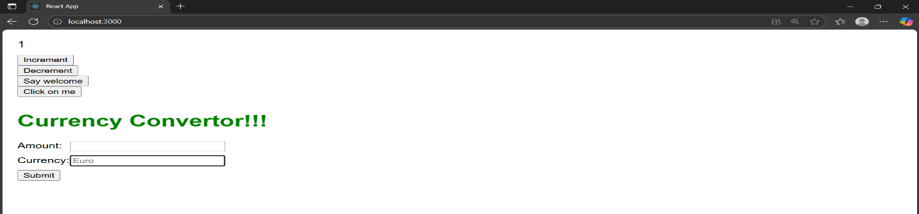

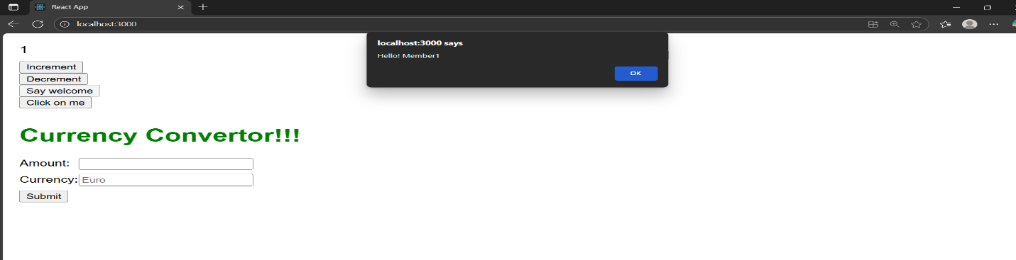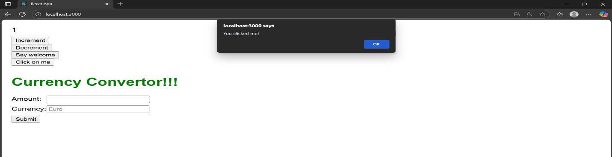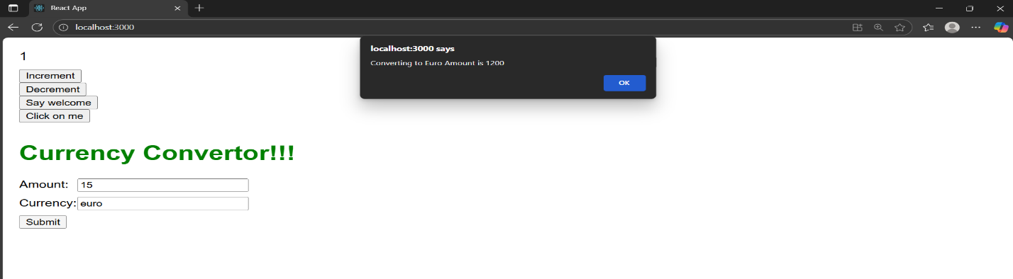

File no : 12 ticketbookingapp

**User.js**

import React from 'react';

const User = ({ username }) => {

  return (

    <div>

      <h2>Welcome, {username}!</h2>

      <p>You can now book tickets. Available flights:</p>

      <table border="1" cellPadding="8" style={{ borderCollapse: 'collapse' }}>

        <thead>

          <tr>

            <th>Flight</th>

            <th>Route</th>

            <th>Time</th>

            <th>Action</th>

          </tr>

        </thead>

        <tbody>

          <tr>

            <td>A101</td>

            <td>New York → London</td>

            <td>10:00 AM</td>

            <td><button>Book</button></td>

          </tr>

          <tr>

            <td>B202</td>

            <td>Paris → Tokyo</td>

            <td>3:30 PM</td>

            <td><button>Book</button></td>

          </tr>

          <tr>

            <td>C303</td>

            <td>Sydney → Dubai</td>

            <td>9:45 PM</td>

            <td><button>Book</button></td>

          </tr>

        </tbody>

      </table>

    </div>

  );

};

export default User;

**Guests.js**

import React from 'react';

const Guest = () => {

  return (

    <div>

      <h2>Welcome, Guest!</h2>

      <p>Browse available flights below:</p>

      <ul>

        <li>Flight A101 — New York to London — 10:00 AM</li>

        <li>Flight B202 — Paris to Tokyo — 3:30 PM</li>

        <li>Flight C303 — Sydney to Dubai — 9:45 PM</li>

      </ul>

    </div>

  );

};

export default Guest;

**App.js**

import React from 'react';

import Guest from './components/Guest';

import User from './components/User';

class App extends React.Component {

  constructor(props) {

    super(props);

    this.state = {

      loggedIn: false,

      username: 'JohnDoe'

    };

  }

  handleLogin = () => {

    this.setState({ loggedIn: true });

  };

  handleLogout = () => {

    this.setState({ loggedIn: false });

  };

  render() {

    // Element variable for conditional rendering

    let content;

    if (this.state.loggedIn) {

      content = <User username={this.state.username} />;

    } else {

      content = <Guest />;

    }

    return (

      <div style={{ padding: 20, fontFamily: 'Arial, sans-serif' }}>

        <h1>Ticket Booking App</h1>

        {/* Login / Logout control */}

        <div style={{ marginBottom: 20 }}>

          {this.state.loggedIn ? (

            <button onClick={this.handleLogout}>Logout</button>

          ) : (

            <button onClick={this.handleLogin}>Login</button>

          )}

        </div>

        {/* Conditionally show content; if not logged in, user cannot see booking actions in User component won't render */}

        {content}

      </div>

    );

  }

}

export default App;

**OUTPUT:**

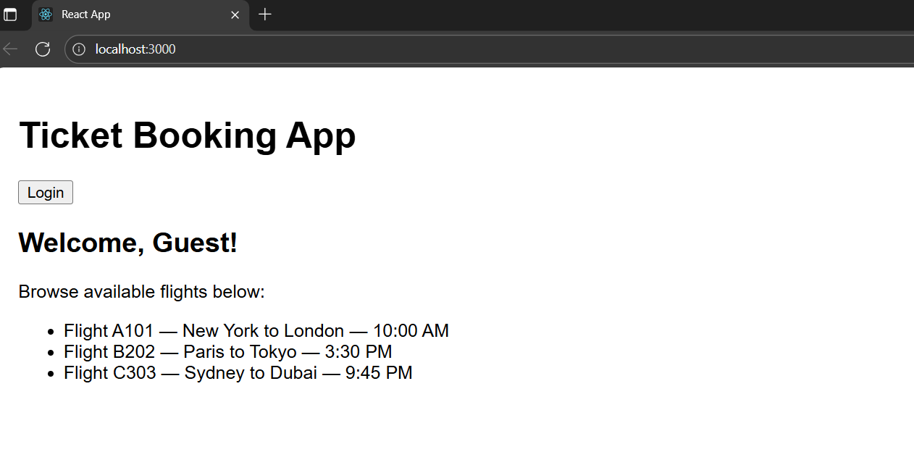

**File no 13: bloggerapp**

Src/Components

BlogDetails.js

import React from "react";

import { blogs } from "../data";

export default function BlogDetails() {

  return (

    <div className="card">

      <h2>Blog Details</h2>

      {blogs.map((b) => (

        <div key={b.id} className="item">

          <h2>{b.heading}</h2>

          <p style={{ fontWeight: "600" }}>{b.author}</p>

          <div style={{ marginTop: "1rem" }}>

            <h2>{b.subHeading}</h2>

            <p>{b.content}</p>

            <p style={{ fontStyle: "bold" }}>{b.note}</p>

            <p style={{ fontWeight: "bold" }}>{b.footer}</p>

          </div>

        </div>

      ))}

    </div>

  );

}

**BookDetails.js**

import React from "react";

import { books } from "../data";

export default function BookDetails() {

  return (

    <div className="card">

      <h2>Book Details</h2>

      {books.map((b) => (

        <div key={b.id} className="item">

          <p style={{ fontWeight: "bold" }}>{b.title}</p>

          <p>{b.pages}</p>

        </div>

      ))}

    </div>

  );

}

**CourseDetails.js**

import React from "react";

import { courses } from "../data";

export default function CourseDetails() {

  return (

    <div className="card">

      <h2>Course Details</h2>

      {courses.map((c) => (

        <div key={c.id} className="item">

          <h3>{c.name}</h3>

          <p>{c.date}</p>

        </div>

      ))}

    </div>

  );

}

**App.js**

import React from "react";

import CourseDetails from "./Components/CourseDetails";

import BookDetails from "./Components/BookDetails";

import BlogDetails from "./Components/BlogDetails";

import "./App.css";

function App() {

  return (

    <div className="container">

      <CourseDetails />

      <BookDetails />

      <BlogDetails />

    </div>

  );

}

export default App;

**App.css**

body {

  font-family: system-ui, -apple-system, BlinkMacSystemFont, "Segoe UI", Roboto,

    "Helvetica Neue", Arial, sans-serif;

  margin: 0;

  padding: 0;

}

.container {

  display: flex;

  gap: 40px;

  padding: 40px;

  justify-content: center;

}

.container {

  display: flex;

  gap: 10px; /* columns madhil space kammi */

  padding: 30px;

  justify-content: center;

  align-items: flex-start;

}

.card {

  flex: 1;

  border-left: 1px solid #117a1d; /* super thin green line */

  padding-left: 12px; /* inside space konjam kammi */

  min-width: 180px;

}

body, h1, h2, h3, h4, h5, h6, {

  font-weight : bold;

}

.card {

  flex: 1;

  border-left: 6px solid #117a1d; /* green vertical bar */

  padding-left: 20px;

  min-width: 200px;

}

.card h2 {

  margin-top: 0;

  font-size: 1.5rem;

}

.item h3 {

  margin: 0;

  font-size: 1.25rem;

}

.item p {

  margin: 4px 0;

}

**Data.js**

export const courses = [

  { id: 1, name: "Angular", date: "4/5/2021" },

  { id: 2, name: "React", date: "6/3/2021" },

];

export const books = [

  { id: 1, title: "Master React", pages: 670 },

  { id: 2, title: "Deep Dive into Angular 11", pages: 800 },

  { id: 3, title: "Mongo Essentials", pages: 450 },

];

export const blogs = [

  {

    id: 1,

    heading: "React Learning",

    author: "Stephen Biz",

    content: "Welcome to learning React!",

    paragraph: "Installation",

    note:"Schewzdienier",

    footer: "You can install React from npm." ,

  },

];

OUTPUT:

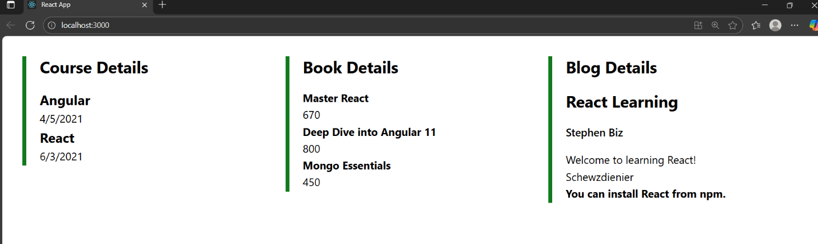

File no 14:employeesapp

Employee.js

// Employee.js

class Employee {

  constructor(id, name, email, phone) {

    this.id = id;

    this.name = name;

    this.email = email;

    this.phone = phone;

  }

}

const EmployeesData = [

  new Employee(101, "Jojo", "jojo@congizant.com", "98238971234"),

  new Employee(102, "Sam", "sam@congizant.com", "9981184126"),

  new Employee(103, "Elisa", "elisa@cognizant.com", "9989389735"),

];

export default Employee;

export { EmployeesData };

EmployeeCard.js

import React, { useContext } from "react";

import Styles from "./EmployeeCard.module.css";

import ThemeContext from "./ThemeContext";

function EmployeeCard({ employee }) {

  const theme = useContext(ThemeContext);

  return (

    <div className={Styles.Card}>

      <h3>{employee.name}</h3>

      <p>{employee.email}</p>

      <p>{employee.phone}</p>

      <p>

        <a href="#" className={theme}>

          Edit

        </a>{" "}

        <a href="#" className={theme}>

          Delete

        </a>

      </p>

    </div>

  );

}

export default EmployeeCard;

**EmployeeCard.module.css**

.Card {

  display: inline-block;

  width: 25%;

  border: 1px solid #999;

  border-radius: 5px;

  margin: 10px;

  padding: 10px;

}

EmployeeList.js

// EmployeesList.js

import EmployeeCard from "./EmployeeCard";

function EmployeesList(props) {

  return (

    <div>

      <h1>Employees List</h1>

      {props.employees.map((employee) => (

        <EmployeeCard employee={employee} key={employee.id} />

      ))}

    </div>

  );

}

export default EmployeesList;

**App.css**

body {

  font-family: system-ui, -apple-system, BlinkMacSystemFont, "Segoe UI", Roboto,

    "Helvetica Neue", Arial, sans-serif;

  margin: 0;

  padding: 0;

}

body,

h1,

h2,

h3,

h4,

h5,

h6,

p,

label,

option,

select,

a {

  font-weight: bold;

}

a {

  display: inline-block;

  margin: 3px 5px;

  padding: 5px 5px;

  border-radius: 3px;

  text-decoration: none;

}

a.dark {

  background-color: #333;

  color: #eee;

}

a.light {

  background-color: #eee;

  color: #333;

}

**ThemeContext.js**

import React from "react";

// default theme is "light"

const ThemeContext = React.createContext("light");

export default ThemeContext;

**OUTPUT:**

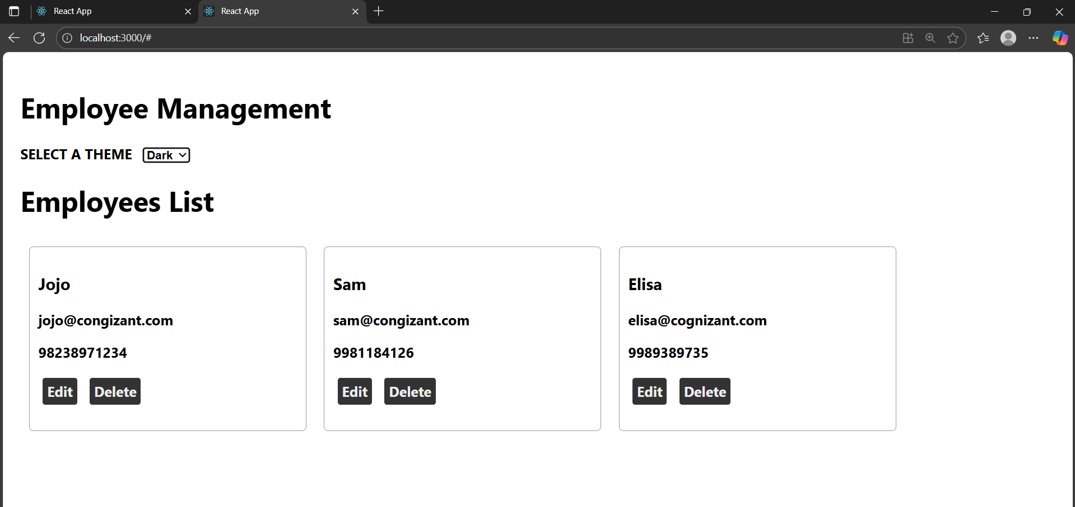

**File no 15: tiketraisingapp**

**ComplaintRegister.js**

import React, { useState } from "react";

function ComplaintRegister() {

  const [name, setName] = useState("");

  const [complaint, setComplaint] = useState("");

  const handleSubmit = (e) => {

    e.preventDefault();

    if (!name.trim() || !complaint.trim()) {

      alert("Please provide both name and complaint.");

      return;

    }

    const transactionId = Math.floor(1000 + Math.random() * 9000); // 4-digit

    alert(

      `Thanks ${name}\nYour Complaint was Submitted.\nTransaction ID is: ${transactionId}`

    );

    setName("");

    setComplaint("");

  };

  return (

    <div style={{ marginTop: 20 }}>

      <h1 style={{ color: "red", textAlign: "center" }}>

        Register your complaints here!!!

      </h1>

      <form

        onSubmit={handleSubmit}

        style={{

          display: "inline-block",

          marginTop: 10,

        }}

      >

        <div style={{ marginBottom: 8 }}>

          <label style={{ marginRight: 8, fontWeight: "bold" }}>Name:</label>

          <input

            type="text"

            value={name}

            onChange={(e) => setName(e.target.value)}

            style={{ padding: "4px", width: 200 }}

          />

        </div>

        <div style={{ marginBottom: 8 }}>

          <label style={{ marginRight: 8, fontWeight: "bold" }}>

            Complaint:

          </label>

          <textarea

            value={complaint}

            onChange={(e) => setComplaint(e.target.value)}

            rows={3}

            style={{ padding: "4px", width: 200, verticalAlign: "top" }}

          ></textarea>

        </div>

        <div>

          <button type="submit" style={{ padding: "6px 14px" }}>

            Submit

          </button>

        </div>

      </form>

    </div>

  );

}

export default ComplaintRegister;

**App.js**

import React from "react";

import ComplaintRegister from "./ComplaintRegister";

function App() {

  return (

    <div>

      <h1 style={{ textAlign: "center" }}>Ticket Raising App</h1>

      <ComplaintRegister />

    </div>

  );

}

export default App;

**OUTPUT:**

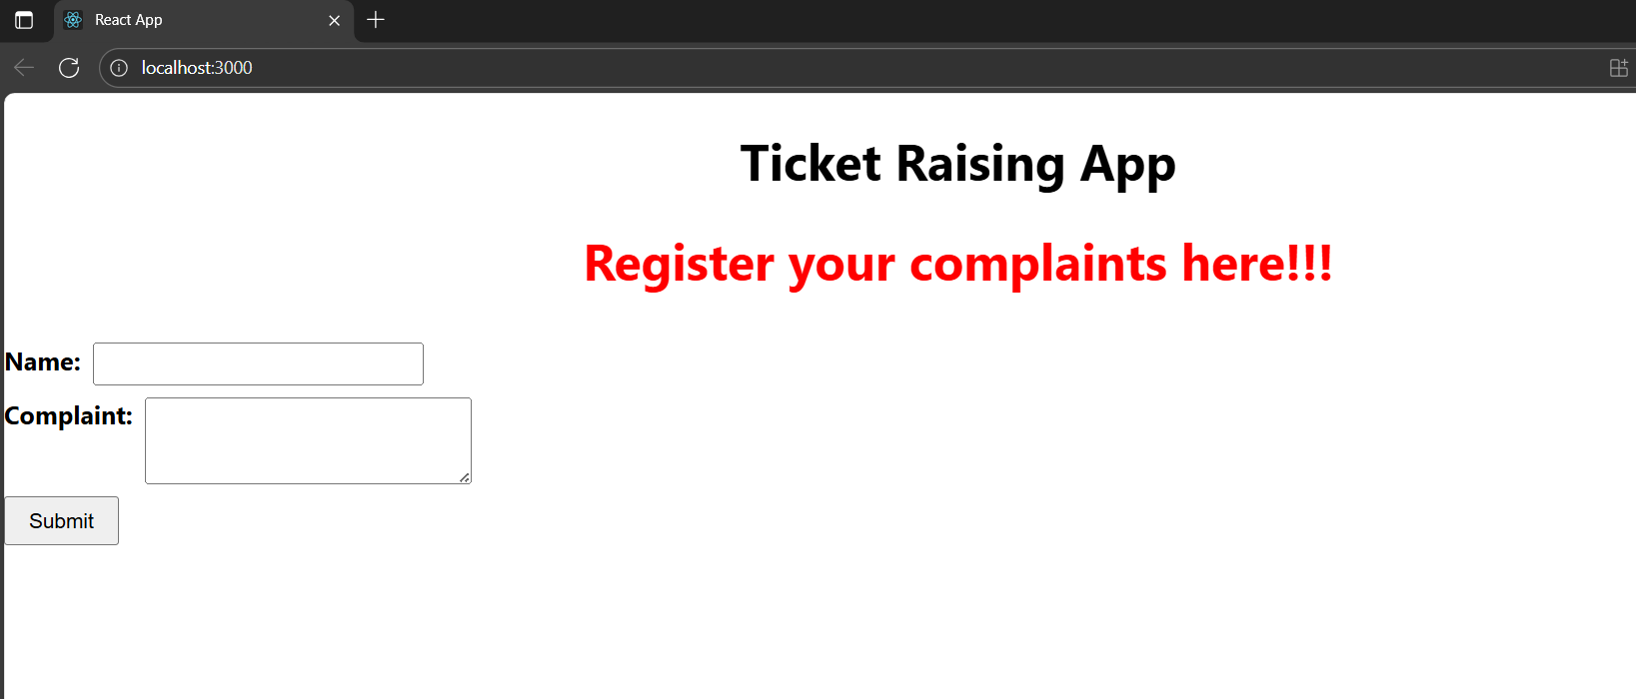

**File name: 16.ReactJS-HOL**

**Register.js:**

import React, { useState } from 'react';

function Register() {

  const [name, setName] = useState('');

  const [email, setEmail] = useState('');

  const [password, setPassword] = useState('');

  const [errors, setErrors] = useState({});

  const validate = () => {

    let errors = {};

    if (name.trim().length < 5) {

      errors.name = 'Name must be at least 5 characters';

    }

    if (!email.includes('@') || !email.includes('.')) {

      errors.email = 'Email must contain "@" and "."';

    }

    if (password.length < 8) {

      errors.password = 'Password must be at least 8 characters';

    }

    return errors;

  };

  const handleSubmit = (e) => {

    e.preventDefault();

    const validationErrors = validate();

    setErrors(validationErrors);

    if (Object.keys(validationErrors).length === 0) {

      alert('Registration Successful!');

      setName('');

      setEmail('');

      setPassword('');

    }

  };

  return (

    <div style={{ width: '400px', margin: '0 auto', padding: '20px' }}>

      <h2 style={{ color: 'blue', textAlign: 'center' }}>Register Here</h2>

      <form onSubmit={handleSubmit}>

        <div>

          <label>Name:</label><br />

          <input

            type="text"

            value={name}

            onChange={(e) => setName(e.target.value)}

          />

          {errors.name && <p style={{ color: 'red' }}>{errors.name}</p>}

        </div>

        <div>

          <label>Email:</label><br />

          <input

            type="email"

            value={email}

            onChange={(e) => setEmail(e.target.value)}

          />

          {errors.email && <p style={{ color: 'red' }}>{errors.email}</p>}

        </div>

        <div>

          <label>Password:</label><br />

          <input

            type="password"

            value={password}

            onChange={(e) => setPassword(e.target.value)}

          />

          {errors.password && <p style={{ color: 'red' }}>{errors.password}</p>}

        </div>

        <br />

        <button type="submit">Register</button>

      </form>

    </div>

  );

}

export default Register;

**App.js:**

import React from 'react';

import Register from './components/register';

function App() {

  return (

    <div className="App">

      <Register />

    </div>

  );

}

export default App;

**Output:**

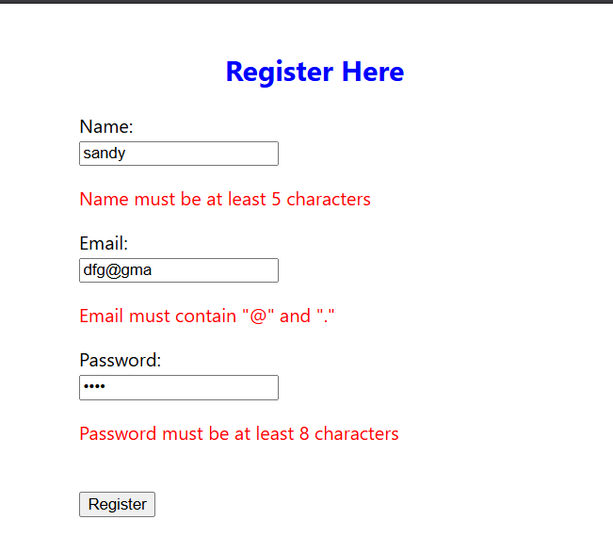

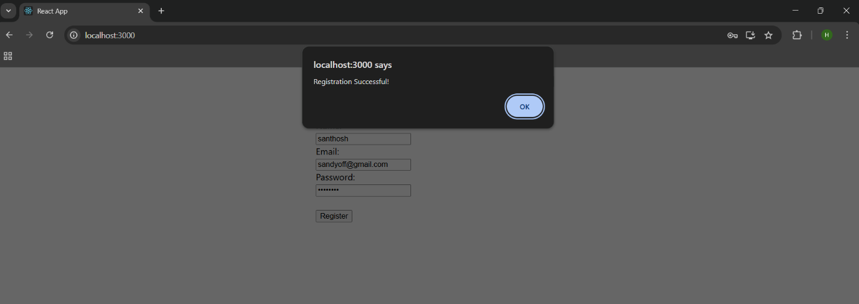

**File name: 17.ReactJS-HOL**

**GetUser.js:**

import React, { Component } from 'react';

class Getuser extends Component {

  constructor(props) {

    super(props);

    this.state = {

      firstName: '',

      imageUrl: '',

    };

  }

  componentDidMount() {

    // Generate a random ID between 1 and 70 (pravatar supports 1–70)

    const randomId = Math.floor(Math.random() * 70) + 1;

    const fakeNames = ['Alice', 'Bob', 'Charlie', 'David', 'Eva', 'Frank', 'Grace', 'Henry'];

    const randomName = fakeNames[Math.floor(Math.random() * fakeNames.length)];

    this.setState({

      firstName: randomName,

      imageUrl: `https://i.pravatar.cc/150?img=${randomId}`,

    });

  }

  render() {

    const { firstName, imageUrl } = this.state;

    return (

      <div style={{ textAlign: 'center', marginTop: '50px' }}>

        <h2>User Profile    </h2>

        <p><strong>First Name:</strong> {firstName}</p>

        {imageUrl ? (

          <img src={imageUrl} alt="User" width="150" height="150" style={{ borderRadius: '50%' }} />

        ) : (

          <p>Loading image...</p>

        )}

      </div>

    );

  }

}

export default Getuser;

**App.js:**

import React from 'react';

import Getuser from './components/GetUser';

function App() {

  return (

    <div className="App">

      <Getuser />

    </div>

  );

}

export default App;

**Output:**

